Statement of Purpose

The purpose of our project is to create an 8-point FFT processor. It works by transforming eight sequential time-domain samples of an input signal into eight corresponding frequency-domain bins.

System Diagram
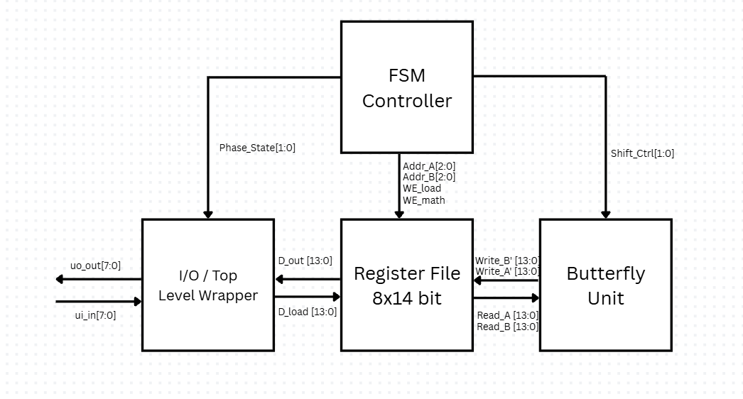

Our design is broken into four main hardware blocks:

The I/O Wrapper interfaces with Tiny Tapeout’s 8-bit physical pins. During the Load phase (cycles 1-8), it streams in 8 real-valued samples over ui_in and formats them into our internal 14-bit complex format: 7 bits for real, and 7 bits for imaginary, initialized to zero.

These values write through a Write MUX directly into our Register File. This block stores 8 complex numbers and serves as our shared memory space for in-place FFT calculations.

The actual logic calculations are driven entirely by the Butterfly Unit, which computes complex sum and difference terms. To stay under our gate limit, instead of using 12 butterfly units (fully expanded 3 stages of 4 calculations), we use a single shared butterfly block driven by multiplexers and shift-and-add logic.
Finally, the entire pipeline is coordinated by our FSM Controller. It generates all address lines and write enables, driving 12 compute steps before triggering the Unload phase (cycles 21–36), which streams the 8 final complex results out as 16 byte transmissions over uo_out.

I/O Pin Assignment Table (Tiny Tapeout Pins)

I/O pin assignment table (Tiny Tapeout pins)

Name | Count | Direction | Description
clk | 1 | Input | Clock input
rst_n | 1 | Input | Active low reset
ui_in[7:0] | 8 | Input | 8 bit input in time domain
uo_out[7:0] | 8 | Output | 8 bit output in frequency domain
uio[0] | 1 | Bidir | is_valid_input
uio[1] | 1 | Bidir | is_valid_output
uio[7:2] | 6 | Bidir | Unused

Proposed Specification

Architecture Type: Radix-2 Decimation-In-Time (DIT), Folded Serial Datapath
Target Platform: Tiny Tapeout (GF180nm), <= 2000 Gate Equivalents

Performance and Timing
Max Clock Frequency: 50 MHz (constrained by I/O wrapper). Execution Latency: 36 clock cycles per complete transform.
Load Phase: 8 cycles (1 real sample per cycle).
Compute Phase: 12 cycles (1 butterfly operation per cycle).
Stream Phase: 16 cycles (14-bit complex output requires 2 cycles per bin on an 8-bit bus). Maximum Throughput: 1.38 million transforms per second (50 MHz / 36 cycles). Processing Time: 0.72 us to process a full 8-point frame at max clock speed.
Data Representation and I/O
Internal Word Size: 14 bits total per sample.
Real Component: 7 bits (1 sign bit, 6 data bits, two's complement).
Imaginary Component: 7 bits (1 sign bit, 6 data bits, two's complement).
Input Format: 8-bit time-domain samples on the ui_in[7:0] bus.
Because the internal real register is only 7 bits, the hardware applies a truncation mapping to drop the Least Significant Bit (LSB), effectively performing an arithmetic right shift: R_in(real) = ui_in[7:1] R_in(imag) = 0 Output Format: 14-bit complex frequency-domain bins. Because 14 bits exceed the 8-bit uo_out[7:0] bus, output serialization is required. For each frequency bin k: Cycle 2k: uo_out[6:0] = Y_k(real), uo_out[7] = 0 Cycle 2k+1: uo_out[6:0] = Y_k(imag), uo_out[7] = 1 (Imaginary Flag)
Memory and Resource Breakdown Working Memory: 112 bits total
Real Bank: 56 bits (8 words x 7 bits/word).
Imaginary Bank: 56 bits (8 words x 7 bits/word)
A_total = 672 + 210 + 109 + 50 = 1041 GE

Timeline + Dividing Work
What | Due Date | Who Does
Create register file | Oct 15 | Chris
Create FSM controller | Oct 15 | Daniel
Create Butterfly Unit | Nov 1 | Chris
Create I/O (Top-level wrapper) | Nov 1 | Daniel
Integration | Nov 15 | Both
Python CocoTB testing | Nov 30 | Both

References

https://www.youtube.com/watch?v=Ty0JcR6Dvis
https://tinytapeout.com/chips/ttsky25a/tt_um_FFT_engine
https://tinytapeout.com/chips/tt04/tt_um_f_hal_fft

